1. Let’s install redis on linux machine.  
   Link: <https://www.itpanther.com/installing-redis-on-linux-using-a-package-manager/>
2. 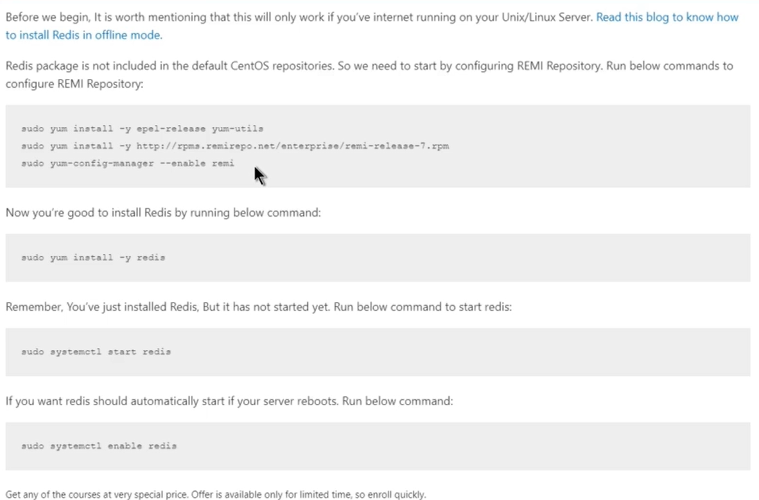
3. After installation, to perform operations on redis through command line, give command redis-cli which is a utility installed along with redis server.
4. **Comamnd** 🡺 redis-cli
5. 